1. **Write a Python Program to Check if a Number is Positive, Negative or Zero?**

**Ans:**

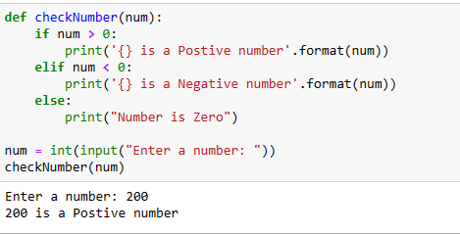

1. **Write a Python Program to Check if a Number is Odd or Even?**

**Ans:**

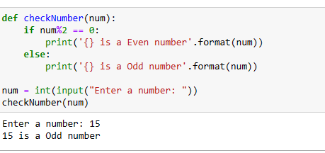

1. **Write a Python Program to Check Leap Year?**

**Ans:**

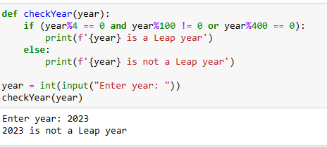

1. **Write a Python Program to Check Prime Number?**

**Ans:**

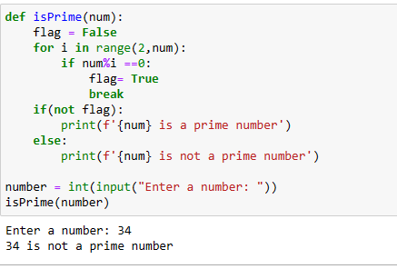

1. **Write a Python Program to Print all Prime Numbers in an Interval of 1-10000?**

**Ans:**

